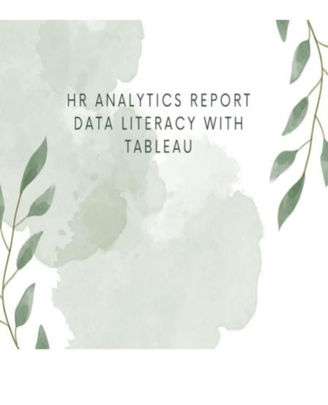

**TEAM ID**

NM2023TMID16031

**MEMBERS**

M.DEVI

S.SHABEENA

S.SHALINI

G.GOMATHI

**PROJECT TITLE**

**HR ANALYTICS WITH TABLEAU**

**PAPER TITLE**

DATA LITERACY WITH TABLEAU

**DETAILS**

III YEAR ,

B.SC., MATHEMATICS,

PG & RESEARCH DEPARTMENT OF MATHEMATICS, KALAIGNAR KARUNANIDHI GOVERNMENT ARTS COLLEGE, TIRUVANNAMALAI.

**UNIVERSITY AFFLIATED**

THIRUVALLUVAR UNIVERSITY, VELLORE

# 1.INTRODUCTION

1.1 Overview

A brief description about our project

An HR analytics project using Tableau involves leveraging Tableau's data visualization and analytics capabilities to gain insights from HR data. Here's a brief description of the steps involved

1. *Data Gathering:* Collect HR data from various sources, such as HRIS systems, spreadsheets, or surveys. This data can include information about employees and more.
2. *Data Preparation:* Cleanse and preprocess the data to ensure it's in a suitable format for analysis.
3. *Connecting to Tableau:* Import the cleaned data into Tableau.
4. *Filtering and Interactivity:* Make the dashboards interactive by adding filters and parameters.

1. *Data Storytelling:* Use Tableau to tell a compelling data story. Explain the significance of our findings and provide actionable insights based on the visualizations.

1. *Sharing and Collaboration:* Share our Tableau dashboards with relevant stakeholders within the HR department and the organization as a whole. Tableau offers options for sharing via Tableau Server or Tableau Online.
2. *Continuous Monitoring:* Continuously update and monitor your HR analytics project as new data becomes available.

8.Ensure that your dashboards stay relevant and provide up-to-date insights.

Different visualization

1.Department wise Attrition

2.No. of employees by Age Group

3.Job Satisfaction Rating

4.Education Field wise Attrition

5.Attrition Rate by Gender For Different Age Group

Using Tableau for HR analytics, we can achieve several significant outcomes and benefits, including:

* + 1. *Data-Driven Decision-Making:* Tableau enables HR profession to base their decisions on data and visual insights rather than intuition. This leads to more informed and effective HR strategies.
    2. *Improved Recruitment:* we can analyze recruitment data to identify the most successful sourcing channels, optimize job postings, and reduce
    3. *Data-Driven Decision-Making:* Tableau enables HR profession to base their decisions on data and visual insights rather than intuition. This leads to more informed and effective HR strategies.
    4. *Improved Recruitment:* we can analyze recruitment data to identify the most successful sourcing channels, optimize job postings, and reduce.
    5. *Data-Driven Decision-Making:* Tableau enables HR profession to base their decisions on data and visual insights rather than intuition. This leads to more informed and effective HR strategies.
    6. *Improved Recruitment:* we can analyze recruitment data to identify the most successful sourcing channels, optimize job postings, and reduce
    7. **\***Reduced Turnover:* By identifying turnover trends and potential causes through Tableau visualizations.
    8. *Enhanced Employee Engagement:* Visualizing employee survey data in Tableau helps HR understand engagement levels.
    9. *Workforce Planning:* Tableau assists in forecasting workforce needs, ensuring that your organization has the right talent in place to meet future demands.
    10. *Talent Development:* You can analyze performance metrics and training data to identify high- potential employees.



1. Problem Definition & Design Thinking

Empathy Map screenshot

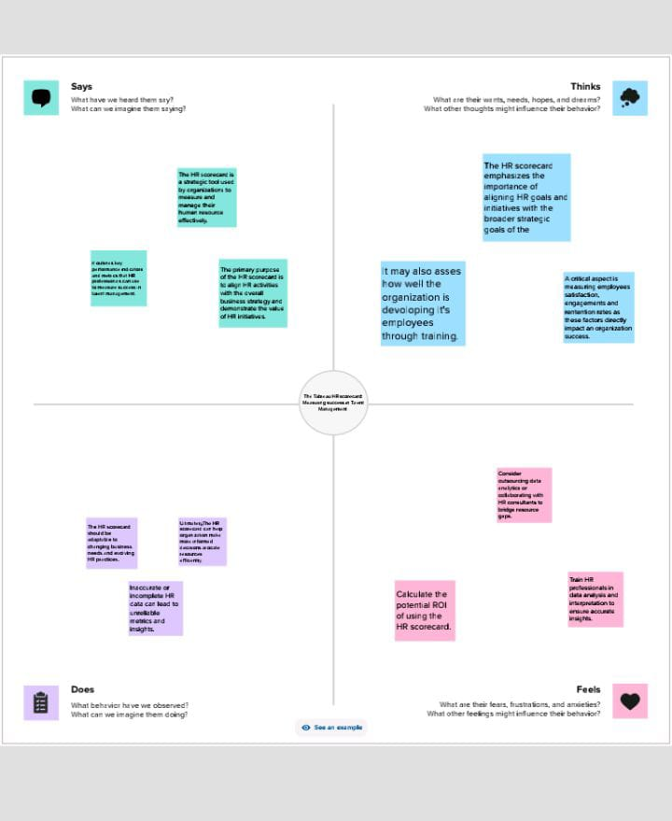

2.2 Brainstorming map screenshots

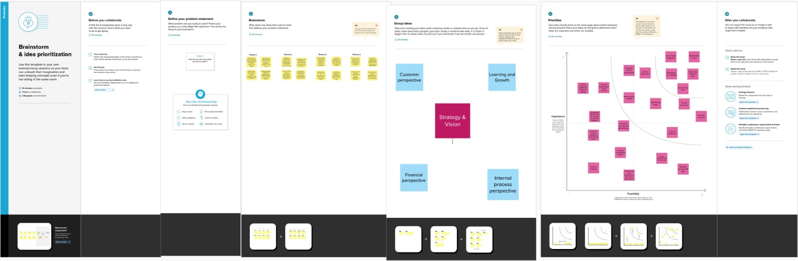

3.RESULT

HR analytics is the process of collecting and analyzing Human Resource (HR) data in order to improve an organization’s workforce performance. The process can also be referred to as talent analytics, people analytics, or even workforce analytics. This method of data analysis takes data that is routinely collected by HR and

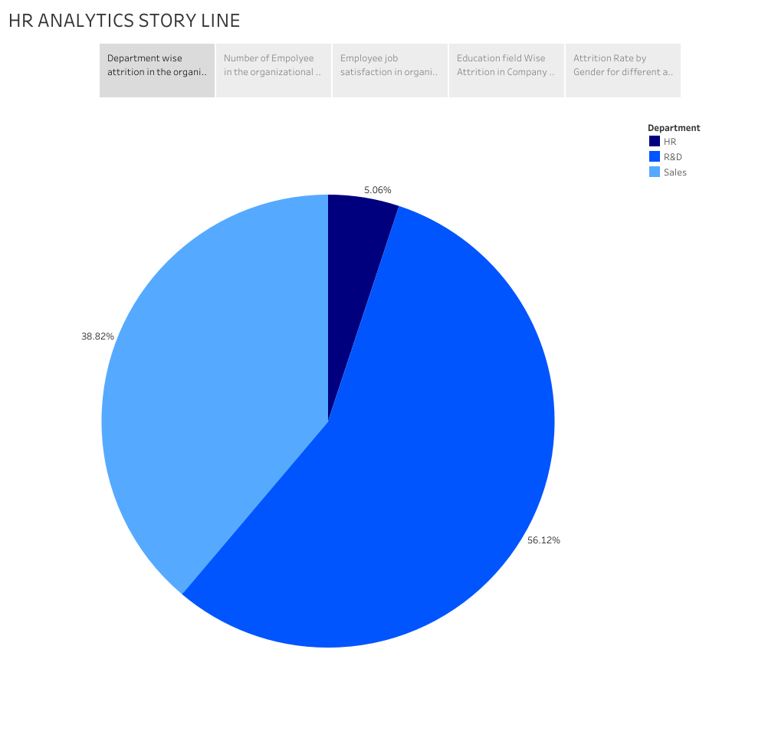

HR ANALYTCS STORY LINE

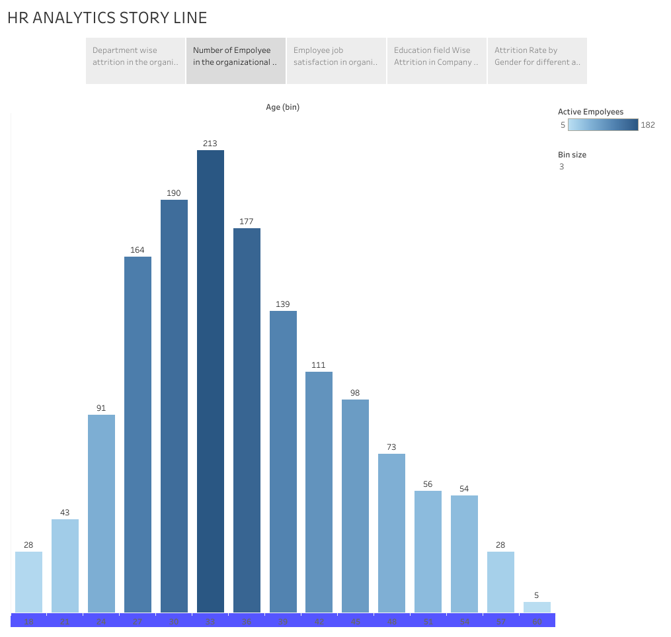

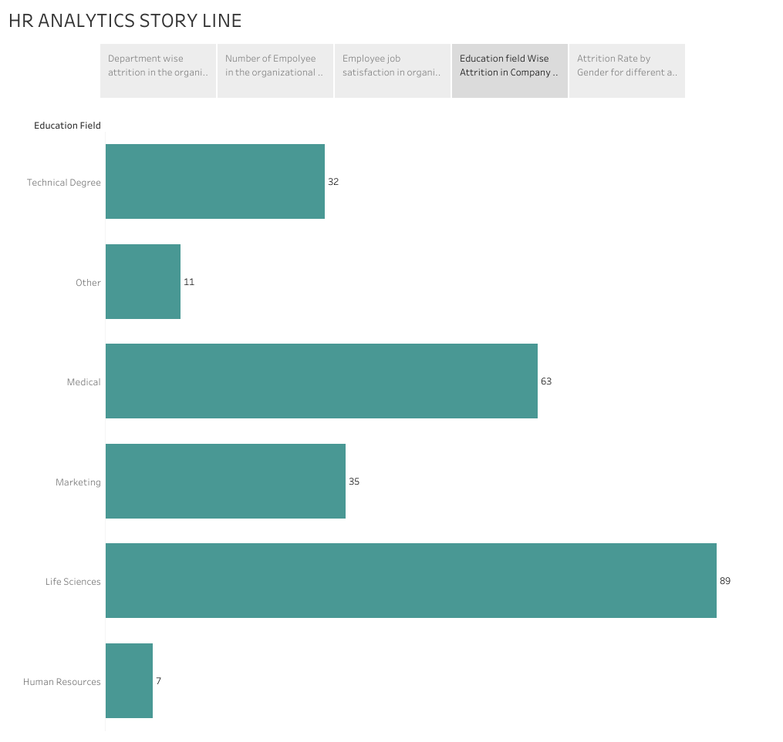

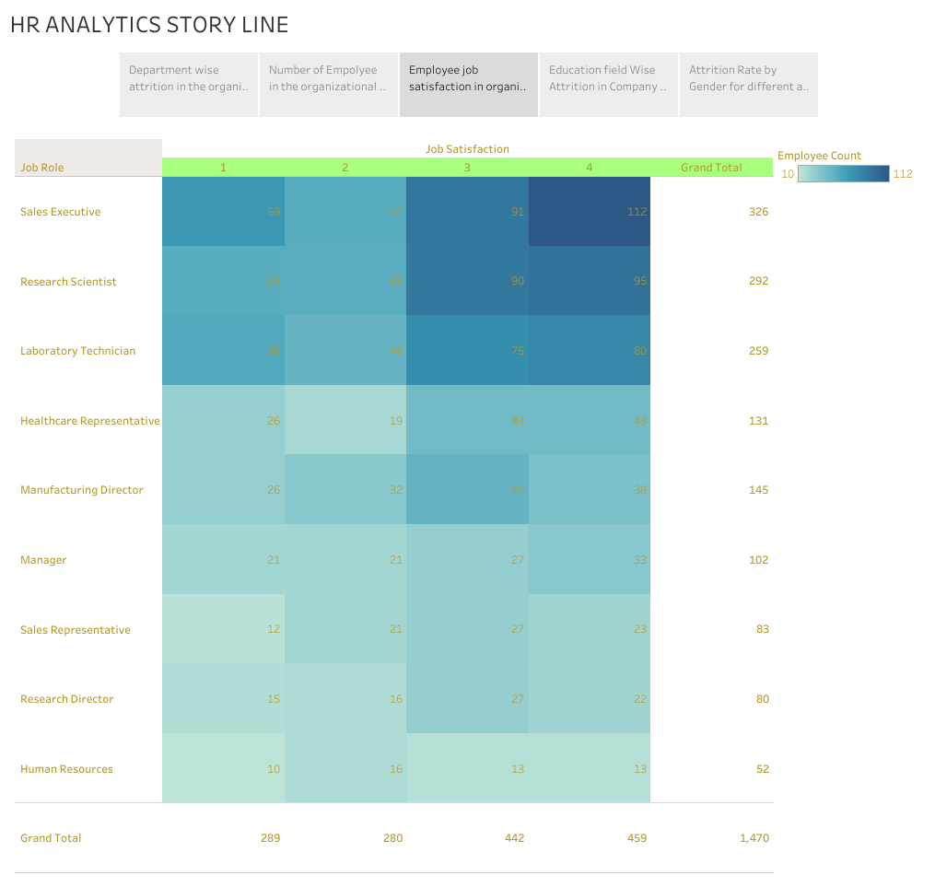

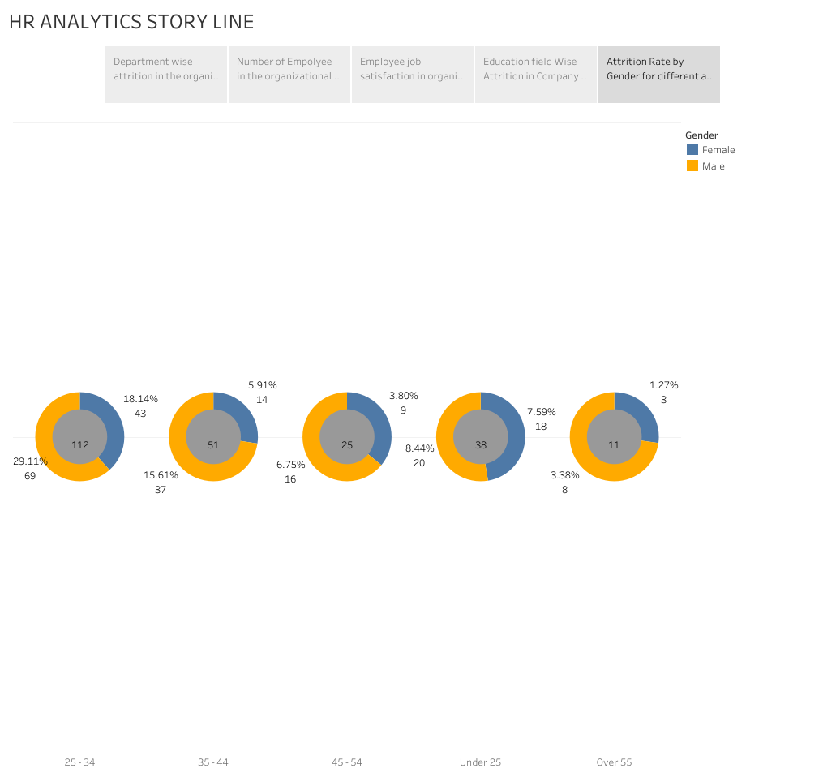

# ADVANTAGES & DISADVANTAGES

Advantages

*Speed:* Tableau can process large datasets quickly, enabling real-time .

*Interactivity:* Interactive dashboards with filters and parameters empower users to explore data.

*Scalability:* Tableau can scale to accommodate the evolving needs of an organization as it grows.

*Collaboration:* Users can collaborate on dashboards and share them easily within the organization using Tableau Server.

Disadvantages

* *Cost:* Tableau can be expensive, especially for enterprise-level deployments.
* *Learning Curve:* Although user-friendly, there is a learning curve to master all of Tableau's features, particularly for complex analysis.

*Data Preparation:* Data cleansing and preprocessing may need to be done outside of Tableau, as it's not a data preparation tool.

*Performance:* Handling extremely large datasets can sometimes lead to performance issues.

*Data Security:* Ensuring data security and compliance with privacy regulations is the responsibility of the organization, and this can be challenging.

*Maintenance:* Keeping Tableau dashboards up to date and relevant requires ongoing effort and resources.

# APPLICATIONS

The areas this solution can be apply are recruitment , talent acquisition , employee retention ,employee engagement, workforce planning , performance management , cost optimization , employee satisfaction , employee feedback etc.,

# CONCLUSION

Leveraging Tableau for HR analytics offers a data-driven solution that empowers organizations to make informed decisions. It enhances recruitment, reduces turnover, and optimizes employee engagement.

However, implementation costs and a learning curve must be considered.

Data quality and security are critical, and continuous improvement is essential for ongoing success in using Tableau for HR analytics.

**Some findings**

* 1. From this department wise attrition chart, it is clear that Research and Development i.e., R&D has higher rate of about 56.12%.
  2. From the representation of employees by age group, maximum is at the age of 32-34 of about 213 and least is 60 years and 5 employees is at the band.
  3. 112 employees from Sales executive role rated 4 by their job satisfaction, 80 Laboratory Technicians follow the list while 69 Sales executive rate 1 for job satisfaction.
  4. 89 employees are from Life Sciences background, Medical science scores second with 63 employees while 7 are from Human Resource background.
  5. 112 employees in 25-34 age groups are attrit.

# FUTURE SCOPE

Tableau in HR Analytics are having more scope in future.

* 1. Increased use of AI and machine learning: The use of AI and

machine learning in HR analytics is expected to increase, allowing businesses to make more accurate predictions and

data-driven decisions.

* 1. Greater emphasis on employee experience: HR analytics will

focus more on employee experience, including employee engagement, satisfaction, and well-being.

* 1. More emphasis on diversity and inclusion: HR analytics will

play a more significant role in promoting diversity and inclusion in the workplace.

* 1. Greater use of predictive analytics: Predictive analytics will

become more prevalent in HR analytics, allowing businesses

to predict future trends and make data-driven decisions accordingly.

* 1. Increased focus on skills development: HR analytics will play

a more significant role in identifying skills gaps and developing training programs to address them.

AI-Driven Insight ,Advanced Predictive Modeling ,Real- Time Analytic ,Augmented Analytics ,Natural Language

Processing ,Enhanced Mobile Experience ,Cybersecurity Measures ,Industry-Specific Templates ,Increased Customization ,Expanded Data Sources ,etc.,.

